**Predictive maintenance of vertical lift storage motor based on machine learning**

Chang-Wu Yang1*,Hu-Fang Liu1,Bei-Sen Lee1

1Department of Information Management, Chaoyang University of Technology

168, Jifeng E. Rd., Wufeng District, Taichung City 413310, Taiwan

*Corresponding author: xxx@xxxx.xxxx

Abstract

Predictive maintenance is one of the key subjects for Industrial 4.0. The purpose of predictive maintenance is to reduce unplanned downtime, to increase productivity and to reduce production costs. In the repetitive procedures of manufacturing & production, raw materials are put into or picked out from storage warehouse and in some cases are replaced with labour-intensive operations using machineries and equipment…

Keywords: Predictive maintenance system, Industrial 4.0, Machine learning, Artificial neural network (ANN)

**1. Introduction**

With the rise of Industrial 4.0 as proposed in Germany the number of manufacturers towards industrial 4.0 keep increasing. Zhou et al. (2015) proposed the method of transition from Industry 3.0 to Industry 4.0, while Germany developed the implementation plan for Industrial 4.0. The main points of the plan can be summarized with building a network and studying two major themes, i.e., smart factories and intelligent production. Many small and medium-sized enterprises (SMEs) in various countries are having trouble pushing the computerization and automation in their plants, not to mention the Industrial 4.0 (Chen, 1911; Lin et al., 2016)…

**2. Materials and Methods**

2.1 Establishment of Predictive Process

Automatic storage warehouse is an important part of the rapid development of modern logistics system. To obtain the current variation log, we added the current sensor as shown in Fig. 1(a) to extract the current data from the vertical lift motor. And the load current is plotted as shown in Fig. 1(b).

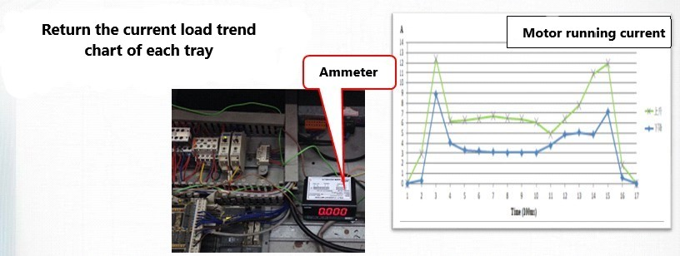

1. (b)

Fig. 1. (a) Setup a current sensor on the motor of vertical lift (left). (b) current plot (right)

Table 1. Transfer the sensor log data into training data

|  |  |  |  |  |  |  |  |  |  |  |  |
| --- | --- | --- | --- | --- | --- | --- | --- | --- | --- | --- | --- |
| *no* | *a1* | *a2* | *a3* | *a4* | *a5* | *a6* | *a7* | *a8* | *a9* | *a10* | *cls* |
| 120 | 1.847 | 6.439 | 3.422 | 3.206 | 3.551 | 4.103 | 4.68 | 4.511 | 7.136 | 0.34 | **0** |
| 121 | 8.215 | 8.859 | 5.503 | 5.63 | 5.158 | 6.451 | 10.628 | 11.152 | 0.728 | 0 | **1** |
| : | : | : | : | : | : | : | : | : | : | : | : |

**3. Results and Discussion**

We have demonstrated that a machine learning method via BPN neural network model can be useful for predictive maintenance of vertical lift storage motor. To extract the data from motor, we added the ammeter to collect the current data and to detect if the motor is rising or falling. Total 123 records are used in this research for training, validating, and testing so that the predictive model is built. The current values are transferred as a1~a10 and is used as input of the predictive model and “*cls*” is used as the target value. The results of our proposed model are as shown in Table 3, where the correction rate under training and testing is 99% and 91%, respectively.

**4. Conclusion**

The traditional vertical lift storage operation is that the personnel who supervises the equipment needs to inspect the equipment regularly. If the machine needs to be repaired and it happens that it is difficult to repair, in this case, any downtime will result in wasted production time…

Acknowledgment

This research would like to thank the support of Chaoyang University of Technology, and the partial funding of Ministry of Education, Taiwan.

References

Chang, C.A., Lin, H.D., Lo, C.C., 1977. Tests of pattern change for automated detection of printing faults using computer vision systems. International Journal of Industrial Engineering, 4, 5-13.

Chen, W.F., 1911. “Stability Design of Steel Frames”. CRC Press. Florida. U.S.A.

Liu, B.L., Tzeng, Y.M., 2000. Characterization study of the sporulation Kinetics of Bacillus thuringiensis. Biotechnology and Bioengineering, 68, 11-17.